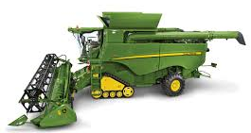
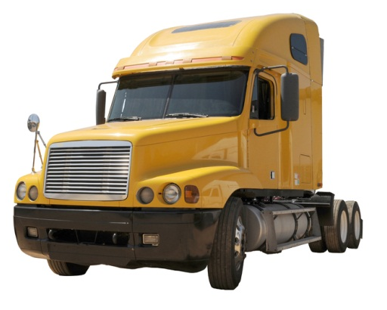
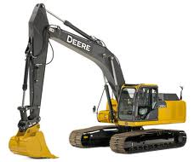
2018
Lube

DataMac®
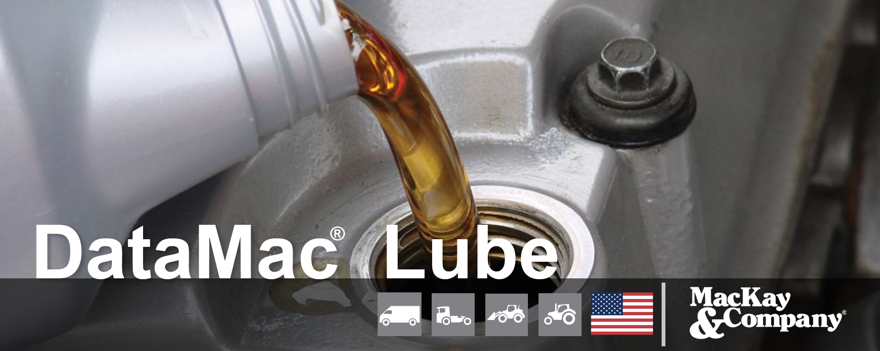

TABLE OF CONTENTS
WHAT IS DATAMAC® LUBE? 4
WHY DATAMAC® LUBE? 5
DATA SOURCE 5
VEHICLES 6
LUBRICANTS & COOLANTS 6
BRANDS 7
VOCATIONS AND/OR EQUIPMENT TYPE 7
FLEET SIZE 8
POINT OF SERVICE 8
CHANNELS OF DISTRIBUTION 8
HISTORY OF DATAMAC® 8
WHO IS MACKAY & COMPANY? 9
DATAMAC® LUBE STAFF 10

DELIVERABLES& PRICING 11
1. Full DataMac® Lube subscriber 11
Annual Report 11
Annual Presentation 11
DataMac® Lube/Coolant Interactive Database 12
On-going Communication 12
Proprietary Research 12
Participation 12
2. Current DataMac® Service Subscribers 13
MACKAY & COMPANY CONTACT 14

WHAT IS DATAMAC® LUBE?
DataMac® Lube is a multi-client service that tracks replacement demand for lubricants and coolants used in on-highway and off-highway vehicles.
DataMac® Lube identifies the total annual U.S. demand in gallons for replacement engine oil, coolant, gear oil and hydraulic transmission fluid.
Demand is further identified by the type of vehicle, vocation, fleet size, point of service, point of final sale, brand used and other relevant factors.
DataMac® Lube began as a detailed aftermarket proprietary study for one of the major oil companies in the mid-1990s and remained a proprietary study until 2005. In 2005, DataMac® Lube became a multi-client subscription service.
In the United States, there are approximately 24.3 million mobile on- and off- types of commercial vehicles and equipment in operation. This includes on-highway trucks and school buses (Class 6 – 8), on-highway light duty vehicles (Class 2c – 5) as well as agriculture equipment such as combines, tractors and construction equipment.
These four combined markets consume over 750 million gallons of lubricants and other fluids (engine oil, coolants, diesel fuel additives, gear oil, hydraulic transmission fluid and oil additives) a year.

WHY DATAMAC® LUBE?
For more than two decades, DataMac® Lube has provided valid, consistent information on size, market share and service habits for the lubricant and coolant replacement markets for on- and off-highway vehicles. Given the detail in DataMac® Lube by market, by lubricant type and by vocation, your company can utilize the data to focus on market strategies. There will be no educated guesses because all of the data is available in our reliable market resource; your company’s decisions will be based on facts.
Our detailed market information is rooted on actual feedback from the equipment owners and operators. MacKay & Company is a leading market research and management consulting firm whose sole focus since 1968 has been, and continues to be, commercial on-highway vehicles, construction equipment, farm field machinery and related components and lubricants.

DATA SOURCE
While some other data services profile the aftermarket for lubricants based on sales to distribution points, DataMac® Lube is different. DataMac® Lube is driven from a ground up perspective of understanding the population of active vehicles, their operating characteristics and their lubricant requirements. All of our data is derived by surveying those companies/owners/fleets who own and maintain the vehicles.
MacKay & Company actively maintains a database of over 250,000 owners and maintainers of commercial vehicles and off-highway farm and construction equipment. The basis of DataMac® is to ask the person who “turns the wrench” (or is responsible for who does) about their vehicle operations and their parts and service purchase habits. They know best what actually happens with their vehicles.
MacKay & Company completes thousands of surveys each year soliciting answers regarding end users’ fleets parts and service practices including vocation, size, average annual hours or miles and types of equipment.

VEHICLE AND EQUIPMENT COVERAGE
DataMac® Lube covers four types of vehicles or equipment:
- DataMac® Lube - CE: Includes heavy and light earthmoving equipment and other types of off-highway construction equipment. Specific types of equipment include crawler dozer/loaders, excavators, wheel loaders, backhoe loaders and skid steers.
- DataMac® Lube - Ag: Details two-wheel and four-wheel tractors, combines and other self-propelled farm equipment.
- DataMac® Lube - Class 6 - 8: Encompasses Class 6 - 8 (19,501 to over 33,001 GVW) on-highway medium and heavy duty trucks and school buses.
- DataMac® Lube - Class 2c - 5: Highlights Class 2c - 5 (8,501 -19,500 GVW)
on-highway commercial vehicles.

LUBRICANTS & COOLANTS
DataMac® Lube identifies and details the total annual U.S. demand in gallons for replacement:
- Engine Oil
  - Single-grade mineral oil
  - Multi-grade mineral oil
  - Synthetic Blend
  - Full Synthetic
- Coolant
  - Extended Life
  - Conventional
  - Other types
- Gear Oil
- Hydraulic Transmission Fluid
- Diesel Fuel Additives
- Oil Additives

BRANDS
DataMac® Lube tracks demand for most major brands of lubricants and coolants.

VOCATIONS AND/OR EQUIPMENT TYPE
Since different applications of vehicles result in different operating characteristics, DataMac® Lube segments markets to provide better profiles (size, brand use, point of removal and replacement, channel of distribution, etc.) by vocation or type of equipment.

FLEET SIZE
Given the notable differences between small fleets and large fleets, DataMac® Lube profiles demand by fleet size. Segmentation by size of fleet varies given the market; Fleet sizes range from 1 - 9 to 500+. With this feature, an analysis can be completed to compare the strengths of brands or distribution channels by fleet size.

POINT OF SERVICE
DataMac® Lube identifies demand by point of service (who removes and replaces engine oil, coolant, diesel fuel additives, gear oil and hydraulic transmission fluid) including original equipment or truck dealers, independent garages, on-site mobile service providers and others if removed or replaced by the operator (end user).

CHANNELS OF DISTRIBUTION
DataMac® Lube identifies demand by channel of distribution (point of final sale). Distribution points include automotive parts stores, engine distributors, club stores (Costco, Sam’s, etc.), equipment dealers (farm, construction or paving), farm co-ops, heavy duty distributors, independent garages, mass merchandisers
(Walmart, Lowe’s, etc.), OE truck dealers, oil companies direct, oil distributors, on-site mobile service providers, quick lube facilities and truck stops.

HISTORY OF DATAMAC®
DataMac® is the term for MacKay & Company's aftermarket tracking services and is used across a variety of markets. The initial DataMac® Truck U.S. studies for the truck and school bus markets were completed in the 1970s and in the early 1980s began as an annual on-going service. Since then, DataMac® has expanded and tracks the replacement demand for over 600 parts and components — from complete engines to drive axles to wheel seals and bearings. In addition, the service covers the farm field and mobile off-highway construction equipment markets and has expanded to include Canada, Mexico and Brazil for the Class 6 - 8 truck, trailer and school bus markets.

WHO IS MACKAY & COMPANY?
MacKay & Company is a specialized management consulting and market research firm. With headquarters in suburban Chicago, the company's focus since 1968 has been, and continues to be, commercial on-highway vehicles, construction equipment, farm field machinery and related components such as engines and transmissions. The scope of the practice includes analyses of original equipment and aftermarket potential, strategic options, distribution policies, product introduction, quality management, acquisitions and a range of related subjects.
The company has 15 full-time employees and maintains joint venture relationships in Brazil, England, France, Germany and Mexico. The company’s senior staff has over 100 years of combined experience in the markets we serve.
For over 30 years, MacKay & Company has been the only provider of detailed aftermarket information for replacement parts and components used on on-highway commercial vehicles and off-highway farm and construction equipment with our DataMac® aftermarket tracking service.
Companies that MacKay & Company has provided DataMac® services to include Accuride Corporation; Allison Transmission; ArvinMeritor, Inc.; Aftermarket Technology Corporation; Baldwin Filters; Bobcat company; (A Doosan Company); CNH Global; Caterpillar Inc.; Chevron Global Lubricants; Cummins Inc.; Daimler Trucks North America; Dana Corporation; Deere & Company; Donaldson Company Inc.; Eaton Corporation; Genuine Parts Company; FleetPride; Hendrickson International; JCB; Mack Trucks, Inc.; Navistar Inc.; PACCAR Inc.; Remy International; Ryder Transportation Services; Shell Oil Company; Volvo Construction Equipment; Volvo Trucks North America; Webb Wheel and Wix Filtration Corporation.
More information on MacKay & Company can be found at www.mackayco.com.

DATAMAC® LUBE STAFF

DataMac® Lube will be under the direction of a team of researchers and analysts. The teams consists of:
Travis Kokenes joined MacKay & Company in December 2007 after receiving his Bachelor of Liberal Arts & Sciences in Communication Studies, with a minor in Business from the University of Kansas.
Travis heads our research department and handles data collection and processing for our DataMac® and proprietary studies. He oversees both our phone and direct mail surveys and is responsible for the design of web-based surveys; working with clients to design questionnaires that fit their specific areas of interest.
Lynn Buck, market analyst, joined MacKay & Company in November of 2012. His background includes over 15 years of data analysis and reporting in a variety of settings. Most recently, he has performed the roles of pricing manager and inventory manager for two aftermarket parts distributors. Prior to that, he analyzed markets for new parts and service locations for Navistar.
Lynn earned a bachelor’s degree in Psychology from Northern Illinois University and an MBA in Finance from North Central College.
Dick Ilseman joined MacKay & Company in September 2014 after 40 years with Navistar International. While at Navistar, Dick moved through a number of management positions in both Truck and Parts. He has a strong background in assembly plant scheduling, demand forecasting, data analysis, distribution and supply chain and inventory management.
While at Navistar, Dick piloted, designed, implemented and supported a vendor-managed inventory system that provided centralized forecasting and inventory replenishment for over 250 of International’s truck dealers. Participating dealers realized significant improvements in inventory turns, fill-rates to customers and reduced obsolescence.
Dick holds a BA degree in Economics from Wabash College and an MBA with a concentration in operations management from the University of Chicago.
Molly MacKay Zacker is MacKay & Company's vice president of operations. In this capacity, she coordinates many behind the scenes activities, manages the research department, writes and proofreads reports and presentations, and conducts research.
Molly holds a bachelor's degree in Economics and Business Management from Goucher College in Towson, Maryland and a Master's degree in Early Childhood Education from Western Michigan University in Kalamazoo, Michigan.

DELIVERABLES & PRICING
Deliverables will be based on your company’s subscription to DataMac® Lube.

1. Full DataMac® Lube subscriber
Companies that participate in full DataMac® Lube will receive the following for each market:

Annual Report
Each participating company will receive a written report (pdf). The final report will include a detailed overview of the survey respondents and the total operating population of vehicles or equipment for each market. Results from non-database questions will be covered in the report. Additionally, the annual report will cover top line database information on market sizes, market shares, point of service, point of final sales, brand use and related topics.

Annual Presentation
MacKay & Company staff members will visit each participating company for a presentation of the findings of our current DataMac® Lube study. In addition,
MacKay & Company will review the DataMac® Lube Database capabilities and offer training to users.

DataMac® Lube/Coolant Interactive Database
Probably the most useful tool of DataMac® Lube, the DataMac® Lube/Coolant interactive Database, will provide the market data in an easy-to-use database with a user-friendly interface for ease of operation. Subscribers will be able to easily review the market information and create tables, charts and graphs of the information as needed. Participating companies will have access to the DataMac® Lube database.
The database can be used to generate charts or data for PowerPoint presentations, Word documents, Excel spreadsheets or similar programs. The Database will include data for each market to which individual companies subscribe.

On-going Communication
DataMac® Lube is structured to be an interactive service. With the depth of information provided, we expect that individual subscribers will have questions. Our professional staff is available to address those questions as they arise within a reasonable time frame.

Proprietary Research
DataMac® Lube is a multi-client service and, as such, each company that participates receives all the information from the base research activities.
MacKay & Company can provide additional proprietary research activities to address individual needs of participating companies.

Participation
Participation in DataMac® Lube is modular and pricing is based on the number of DataMac® Lube markets ordered. The four markets available include on-highway light duty (Class 2c-5), on-highway medium and heavy duty (Class 6-8), off-highway agriculture equipment, and off-highway construction equipment. All markets are for the U.S.

A discounted price is given to those clients who subscribed to one of our DataMac® Lube studies in the previous year.

2. Current DataMac® Service Subscribers (Such as DataMac® Truck, Ag or CE)
If your company is a current subscriber to one of our DataMac® services, such as DataMac® Truck U.S., there will now be an option to add a Lube product category.
Purchasers of the Lube product category will receive:

Annual Report
Each participating company will receive a written report (pdf) for the market of interest. The final report will include a detailed overview of the survey respondents and the total operating population of vehicles or equipment for each market. Results from non-database questions will be covered in the report. Additionally, the annual report will cover top line database information on market sizes, market shares, point of service, point of final sales, brand use and related topics.

Annual Presentation
MacKay & Company staff members will provide each participating company a presentation of the findings of that year's DataMac® Lube study. This can be tied in with the annual Roadshow or as an online meeting. In addition,
MacKay & Company will review the DataMac® Lube Database.

DataMac® Lube/Coolant Interactive Database & Lube Product Category added to base DataMac® service Database
The DataMac® Lube/Coolant Interactive Database will provide the market data in an easy-to-use database with a user friendly interface for ease of operation. Subscribers will be able to easily review the market information and create tables, charts and graphs of the information as needed. Participating companies will have access to the DataMac® Lube database.
While the format is very similar to other DataMac® service databases – this database provides additional information on brand segmentation.
In addition, a Lube product category will be added to the subscribing companies’ base DataMac® service. For example, if you are a current DataMac® Truck U.S. subscriber, a Lube product category will be added to your DataMac® Truck database. It will not include the brand segmentation.
In the event the DataMac® Lube service is not updated in a given year, market sizes and forecast will be updated similarly to other product categories in DataMac® Truck based on changes in operating populations, annual usage and other factors.

Participation
For a reduced cost, subscribers can add the Lube product category to a DataMac® Truck subscription
Similar pricing(50% discount) is available for other markets if your company subscribes to the base DataMac® service.

MACKAY & COMPANY CONTACT
If your company would like to participate in DataMac® Lube or if you have questions regarding DataMac® Lube or any of our other services, please contact John Blodgett, vice president, sales and marketing, at 630-916-6110 or john.blodgett@mackayco.com.

G:\0928/DataMac Lube Prospectus.doc

